

CSA0501-DATABASE MANAGEMENT SYSTEMS

LAB EXPERIMENTS DATE: 27/07/2026

EXPERIMENT 10 – Database with VIEW and INDEX
AIM: To create view and index on the Pet Management System database.

PROCEDURE:
- Select the pet_management database using the USE command.
- Display all records from the pet_details table.
- Create a view v1 using selected columns from the pet_details table.
- Insert a new record into the created view and verify it.
- Delete the inserted record from the view and verify the deletion.
- Create an index on the pet_name column to improve data retrieval.
- Verify the created index using the SHOW INDEX command.
PROGRAM:

1. Display all records:

USE pet_management;

SELECT * FROM pet_details;

OUTPUT:

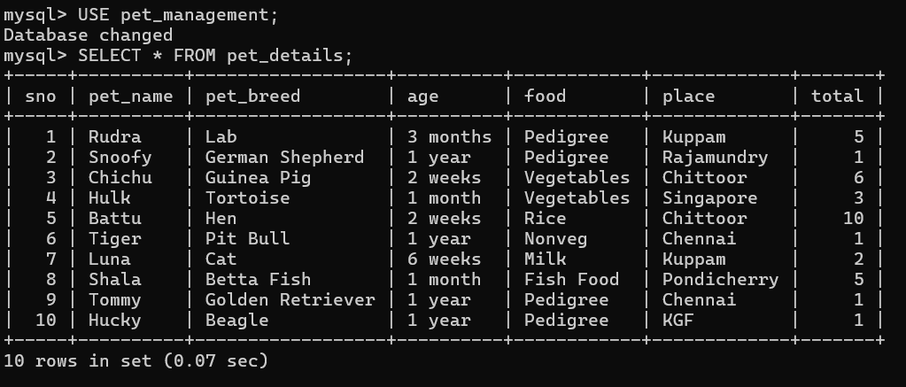

2. Create VIEW
CREATE VIEW v1 AS
SELECT sno, pet_name, total
FROM pet_details;
SELECT * FROM v1;
OUTPUT:

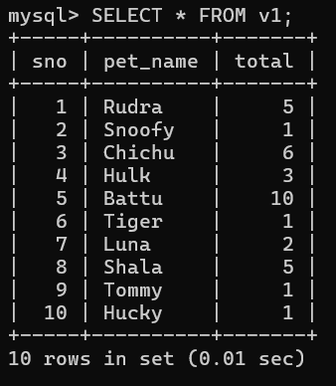

3. Insert a record into VIEW
INSERT INTO v1 (sno, pet_name, total)
VALUES (11, 'Bruno', 4);
SELECT * FROM v1;
OUTPUT:
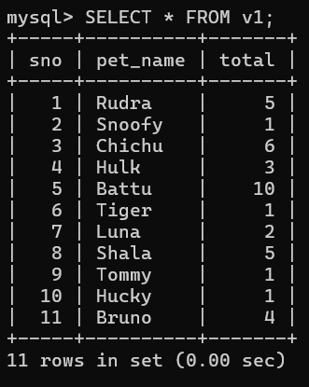

4. Delete a record from VIEW
DELETE FROM v1
WHERE sno = 11;
SELECT * FROM v1;
OUTPUT:

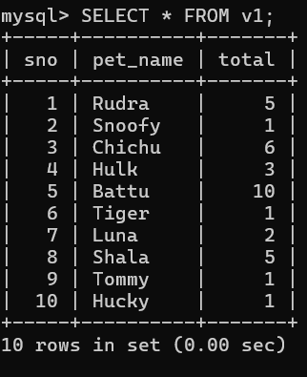

5. Create INDEX
CREATE INDEX idx_pet_name
ON pet_details(pet_name);
SHOW INDEX FROM pet_details;
OUTPUT:

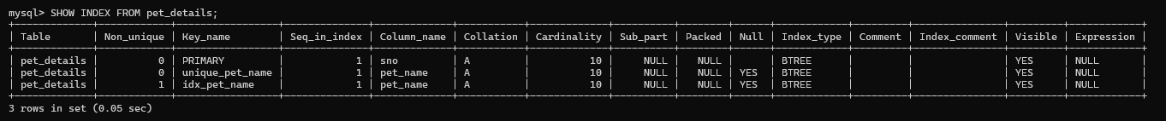

RESULT: The records from the tables are displayed using view and index on the given relation.

